**Practical No:06**

**Swing**

1. **Create a swing application that randomly changes color on button click.**

**Code:**

import javax.swing.*;

import java.awt.*;

import java.util.*;

import java.awt.event.*;

class Demo extends JFrame implements ActionListener

{

JPanel p;

JButton b;

Demo(){

p=new JPanel();

add(p,BorderLayout.CENTER);

b=new JButton("change");

add(b,BorderLayout.SOUTH);

b.addActionListener(this);

setSize(400,500);

setVisible(true);

setDefaultCloseOperation(JFrame.EXIT_ON_CLOSE);

setLayout(new BorderLayout());

}

public void actionPerformed(ActionEvent e)

{

Random r=new Random();

int red=r.nextInt(255);

int blue=r.nextInt(255);

int green=r.nextInt(255);

Color d=new Color(red,blue,green);

p.setBackground(d);

}

public static void main(String args[])

{

new Demo();

}

}

**Output:**

**Before change After change**

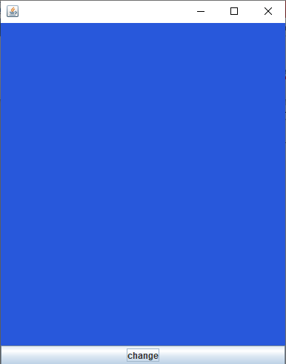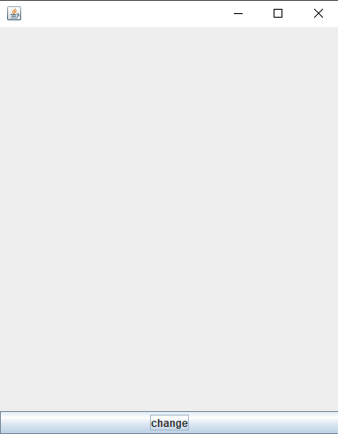

1. **Create a Swing application to demonstrate use of scrollpane to change its color selected using colour chooser.**

**Code:**

import javax.swing.*;

import java.awt.*;

import java.util.*;

import java.awt.event.*;

class Demo extends JFrame implements ActionListener

{

JPanel p;

JButton b;

Demo()

{

p=new JPanel();

add(p,BorderLayout.CENTER);

b=new JButton("change");

add(b,BorderLayout.SOUTH);

b.addActionListener(this);

setSize(400,500);

setVisible(true);

setDefaultCloseOperation(JFrame.EXIT_ON_CLOSE);

setLayout(new BorderLayout());

}

public void actionPerformed(ActionEvent e)

{

Color c=JColorChooser.showDialog(null,"Select color",Color.RED);

p.setBackground(c);

}

public static void main(String args[])

{

new Demo();

}

}

**Output:**

Before selecting color panel

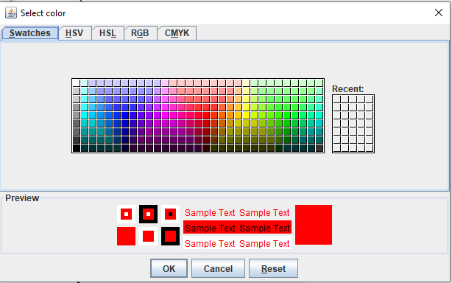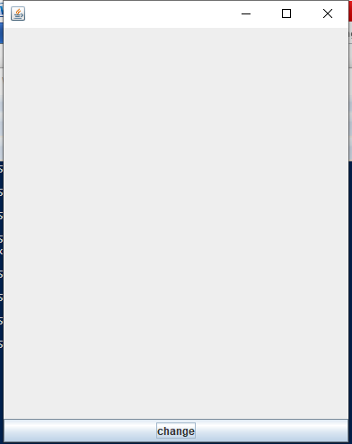 After selecting

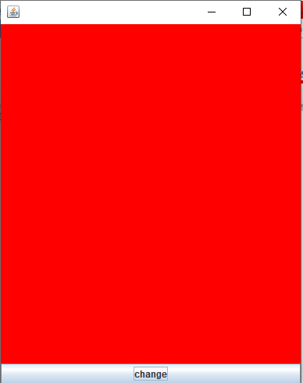

1. **Create a Swing application to demonstrate use of TextArea using scrollpane to show contest of text file in textarea selected using file chooser.**

**Code:**

import java.awt.*;

import javax.swing.*;

import java.util.*;

import java.awt.event.*;

import java.io.*;

class demo extends JFrame implements ActionListener

{

JMenuBar br;

JMenu file;

JMenuItem open,save;

JScrollPane p;

JTextArea a;

demo()

{

br=new JMenuBar();

file=new JMenu("File");

open=new JMenuItem("Open");

save=new JMenuItem("Save");

setJMenuBar(br);

br.add(file);

file.add(open);

file.add(save);

a=new JTextArea(20,30);

p=new JScrollPane(a);

p.setVerticalScrollBarPolicy(JScrollPane.VERTICAL_SCROLLBAR_ALWAYS);

p.setHorizontalScrollBarPolicy(JScrollPane.HORIZONTAL_SCROLLBAR_ALWAYS);

add(p);

setVisible(true);

setSize(400,400);

setDefaultCloseOperation(JFrame.EXIT_ON_CLOSE);

open.addActionListener(this);

save.addActionListener(this);

}

public void actionPerformed(ActionEvent e)

{

if(e.getSource()==open)

{

JFileChooser ch=new JFileChooser();

int res=ch.showOpenDialog(null);

if(res==ch.APPROVE_OPTION)

{

File f=ch.getSelectedFile();

try

{

BufferedReader b=new BufferedReader(new FileReader(f));

String line;

a.setText(" ");

while((line=b.readLine())!=null)

{

a.append(line + "\n");

}

}

catch(IOException ex)

{

JOptionPane.showMessageDialog(ch,"Error");

}

}

}

else if(e.getSource()==save)

{

JFileChooser ch=new JFileChooser();

int resp=ch.showSaveDialog(null);

if(resp==ch.APPROVE_OPTION)

{

File f2=ch.getSelectedFile();

try{

BufferedWriter b=new BufferedWriter(new FileWriter(f2));

b.write(a.getText());

}

catch(IOException ex){

JOptionPane.showMessageDialog(ch,"Error");

}

}

}

}

public static void main(String[] args){

demo d=new demo();

}

}

**Output:**

Before open After open

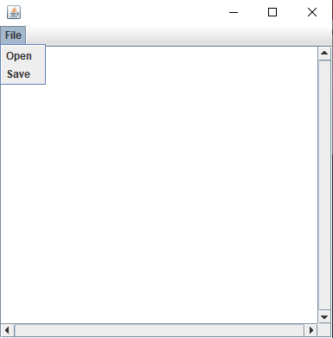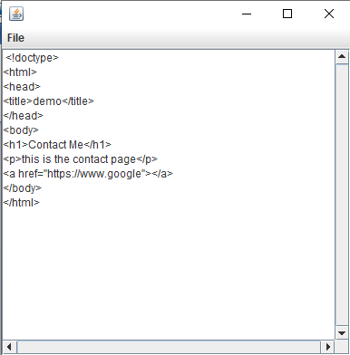

Before save After save

